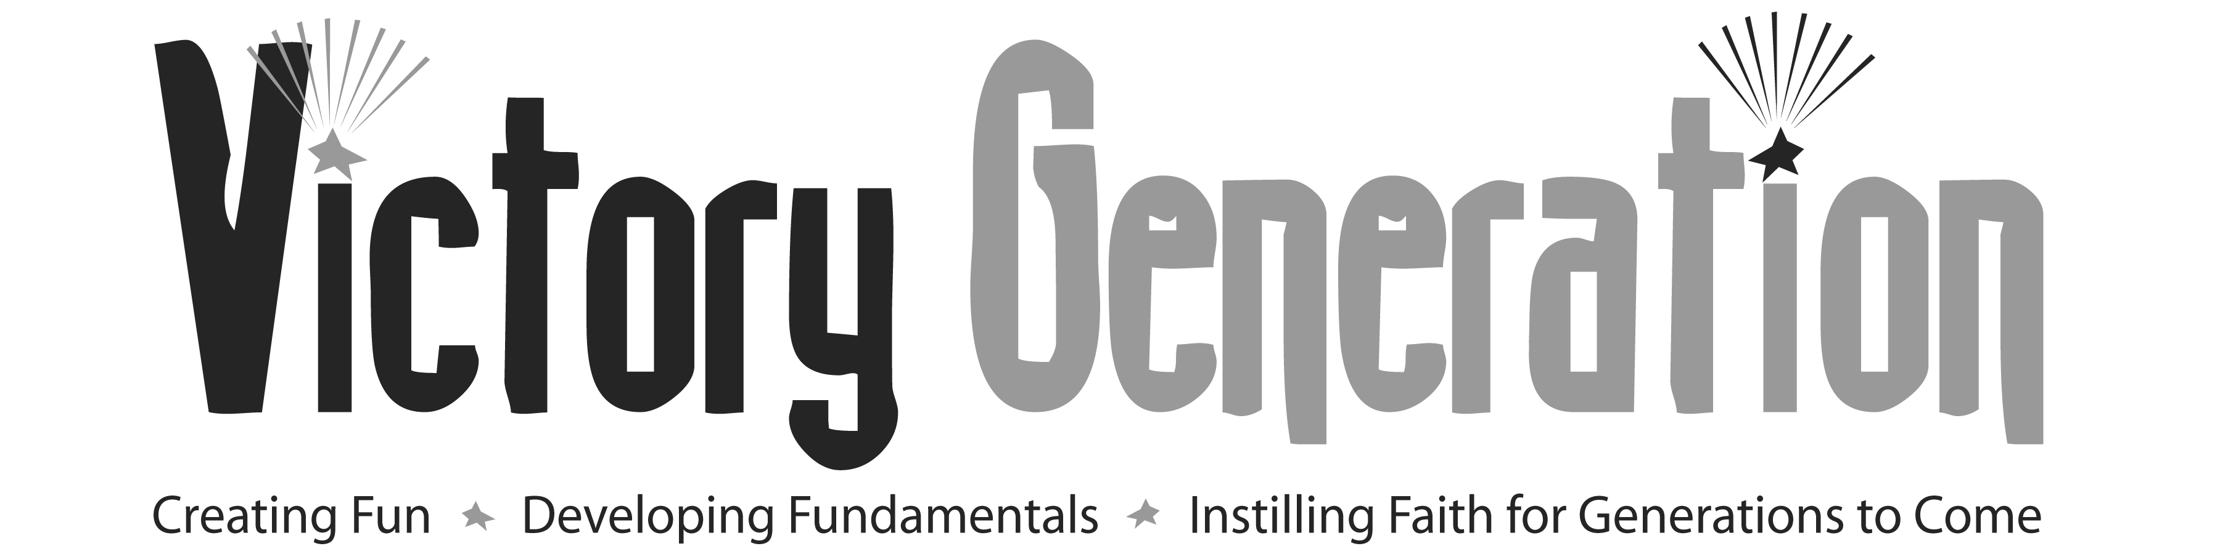

Academic Year 2015-2016

Program Affiliate Site Listing

BMA Main Office Greenwood Shalom Tutoring Zone
2010 Columbus Avenue 378A Washington Street
Roxbury, MA 02119 Dorchester, MA 02124
Phone: 617-445-2737 ext.115 Phone: 617-282-1464
Contact: Henry H. Paige Contact: Rochelle Jones
hhpaige@bmaboston.org greenwoodshalom@gmail.com

Achieve! GRASP Twelfth Baptist Church After-School
Holmes Elementary School The Historic Twelfth Baptist Church
40 School Street 160 Warren Street
Dorchester, MA 02124 Roxbury, MA 02119
Phone: 617-799-0730 Phone: 617-427-5158
Holmes: 617-635-8681 Contact: Rev. Willie Bodrick
Contact: Katherine Allen Combs wbodrick@tbcboston.org
graspforkids@yahoo.com

The Butterfly Project Hamilton-Garrett Music & Arts Academy
Eliot Congregational Church Charles Street A.M.E. Church
56 Dale Street 551 Warren Street
Roxbury, MA 02119 Dorchester, MA 02121
Phone: 617-445-7525 Phone: 857-203-2842
Contact: Marilyn Andry Contact: Elta Garrett
Saturdays Only HGMAA@csrrc.org

Franklin Park Tennis Association Haynes Early Education Center
1542 Columbus Avenue 263 Blue Hill Avenue
Roxbury, MA 02119 Roxbury, MA 02119
Phone: 617-427-8900 Phone: 617-635-6446
Contact: Jeannine Laing Contact: Gerda Audry-Wright
jeannine_laing@hotmail.com gaudrywright@bostonpublicschools.org
www.franklinparktennis.org

